SIMATS ENGINEERING
ASSESSMENT TOOL 2

COURSE NAME: Database Management Systems
COURSE CODE: CSA05

COURSE OUTCOME COVERED

CO2: Apply the relational model, relational algebra, SQL query structures, and views to solve database querying and data manipulation problems. (BL3, BL6)

Activity Tool : Scenario-Based Task (High)
Assessment Tool Weightage: 35%

Dr

QUESTIONS Total Marks: 50
Q.No | Question | Bloom's Level | Marks
1 | Given the scenario of a School Management System, identify relations and write SQL to list all students with their class teacher and grade. | BL3 – Apply | 5
2 | A hospital wants to track patient appointments. Design the relational schema and write SQL to find doctors with more than 10 appointments this month. | BL3 – Apply | 5
3 | In an e-commerce scenario, write SQL queries using sub-queries to find products that have never been ordered. | BL3 – Apply | 5
4 | For a university database, write relational algebra expressions to find students enrolled in both 'DBMS' and 'OS' courses. | BL3 – Apply | 5
5 | Given a payroll scenario, create a view showing employees whose salary is below department average and write a query to update their salary by 10%. | BL6 – Create | 5
6 | In a banking scenario, apply JOIN operations to retrieve customer account details, transaction history, and branch information. | BL3 – Apply | 5
7 | A retail store needs daily sales summary. Write SQL with GROUP BY and HAVING to report total sales per category exceeding Rs. 10,000. | BL3 – Apply | 5
8 | For a library system scenario, construct tuple relational calculus expressions to find members who borrowed books from all genres. | BL3 – Apply | 5
9 | Given an inventory management scenario, define CHECK and FOREIGN KEY constraints and demonstrate their enforcement through SQL. | BL3 – Apply | 5
10 | Design a relational schema for an HR system and create materialized views for monthly attendance and performance summaries. | BL6 – Create | 5

Code of Conduct:

I NITTHYENDREN JS 192421180 certify that this submission is my original work and that I have adhered to the guidelines specified for this assessment.
I understand that any violation of academic integrity rules will result in disciplinary action.

Signature of the student:
NITTHYENDREN JS

RUBRICS FOR CALCULATION:

Scenario based assessment
Criteria | Weightage (%) | Level 4 (Exemplary) | Level 3 (Proficient) | Level 2 (Developing) | Level 1 (Beginning)
Understanding of Scenario | 20% | Demonstrates clear and complete understanding of the scenario and context | Shows good understanding with minor gaps | Partial understanding; misses key aspects | Misinterprets or fails to understand the scenario
Identification of Key Issues | 20% | Accurately identifies all relevant issues and factors involved | Identifies most key issues with minor omissions | Identifies limited issues; some irrelevant points | Unable to identify key issues
Application of Concepts | 25% | Applies appropriate concepts effectively to address the scenario | Applies concepts with minor errors | Limited or partially correct application | Unable to apply relevant concepts
Decision Making | 20% | Makes well-reasoned, logical decisions with strong rationale | Makes reasonable decisions with some justification | Makes weak decisions with limited justification | No clear decisions made or rationale provided
Clarity of Response | 15% | Response is clear, structured, and logically presented | Generally clear with minor issues | Somewhat unclear or poorly structured | Disorganized and difficult to understand

ANSWERS

Q1. School Management System — Students with Class Teacher & Grade — 5 Marks
Scenario understanding & key issues
A school needs to track which teacher handles which class, and which student belongs to which class. Three entities are involved: STUDENT, CLASS and TEACHER, linked by class assignment.
Relations identified
TEACHER (TeacherID PK, TeacherName)
CLASS (ClassID PK, Grade, TeacherID FK -> TEACHER)
STUDENT (StudentID PK, StudentName, ClassID FK -> CLASS)
StudentID | StudentName | ClassID
S1 | Aditi | C1
S2 | Rohan | C2
S3 | Sneha | C1

ClassID | Grade | TeacherID
C1 | 5-A | T1
C2 | 5-B | T2

SQL — list every student with class teacher and grade
SELECT s.StudentName, c.Grade, t.TeacherName AS Class_Teacher
FROM Student s
JOIN Class c ON s.ClassID = c.ClassID
JOIN Teacher t ON c.TeacherID = t.TeacherID
ORDER BY c.Grade, s.StudentName;
Decision rationale: a two-step join (Student→Class→Teacher) is used instead of duplicating teacher/grade columns inside STUDENT, avoiding redundancy and update anomalies if a teacher is reassigned.

Q2. Hospital Appointment Tracking — Schema Design + Busy Doctors — 5 Marks
Scenario understanding
The hospital must record which doctor sees which patient, and when. Doctor and Patient are independent entities; Appointment is an associative (transaction) entity linking them, carrying the date and status — this is the key modelling decision.
Relational Schema
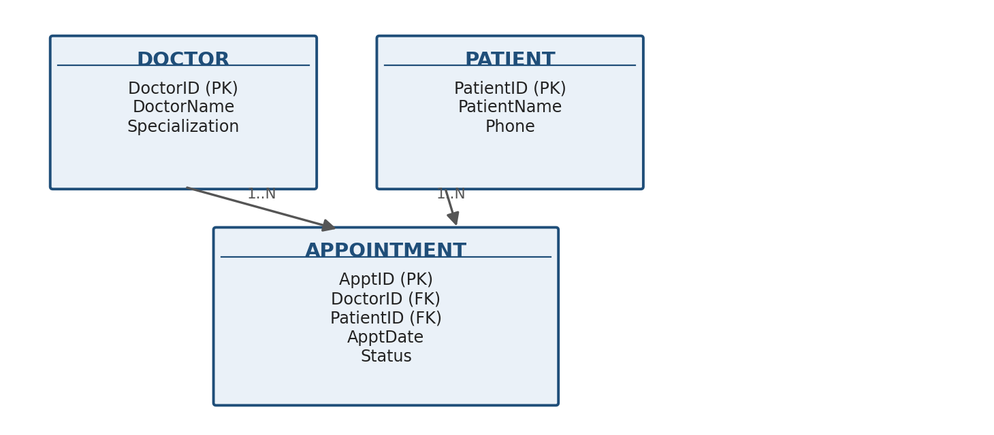

DOCTOR (DoctorID PK, DoctorName, Specialization)
PATIENT (PatientID PK, PatientName, Phone)
APPOINTMENT (ApptID PK, DoctorID FK -> DOCTOR, PatientID FK -> PATIENT,
ApptDate, Status)
SQL — doctors with more than 10 appointments this month
SELECT d.DoctorID, d.DoctorName, COUNT(a.ApptID) AS Appt_Count
FROM Doctor d
JOIN Appointment a ON d.DoctorID = a.DoctorID
WHERE MONTH(a.ApptDate) = MONTH(CURRENT_DATE)
AND YEAR(a.ApptDate) = YEAR(CURRENT_DATE)
GROUP BY d.DoctorID, d.DoctorName
HAVING COUNT(a.ApptID) > 10;
Decision rationale: filtering by month/year is done in WHERE (row-level) before grouping, while the '>10' threshold is a group-level condition and therefore correctly placed in HAVING.

Q3. E-commerce — Products Never Ordered (Sub-query) — 5 Marks
Scenario & schema
PRODUCT (ProductID PK, ProductName, Price)
ORDERITEM (OrderItemID PK, OrderID, ProductID FK -> PRODUCT, Qty)
Method 1 — NOT IN sub-query
SELECT ProductID, ProductName
FROM Product
WHERE ProductID NOT IN (SELECT ProductID FROM OrderItem);
Method 2 — NOT EXISTS (correlated, safer with NULLs)
SELECT p.ProductID, p.ProductName
FROM Product p
WHERE NOT EXISTS (
SELECT 1 FROM OrderItem oi WHERE oi.ProductID = p.ProductID
);
Decision rationale: NOT EXISTS is preferred in production because NOT IN silently returns an empty result if the sub-query's ProductID column contains any NULL — a common, hard-to-spot bug.

Q4. University — Students Enrolled in Both 'DBMS' and 'OS' — 5 Marks
Schema
ENROLLED (SID, CourseName)
Relational Algebra (Set Intersection via two selections + a natural join)
π SID (σ CourseName='DBMS' (Enrolled))
∩
π SID (σ CourseName='OS' (Enrolled))
Equivalent expression without ∩ (self-join form)
π e1.SID ( σ e1.CourseName='DBMS' ∧ e2.CourseName='OS' ∧ e1.SID = e2.SID
( ρ e1 (Enrolled) × ρ e2 (Enrolled) ) )
Decision rationale: intersection directly captures 'both courses'; the self-join form is shown as the equivalent primitive-operator expansion, useful in engines lacking a native ∩ operator.

Q5. Payroll — Below-Average-Salary View + 10% Raise — 5 Marks
CREATE VIEW BelowAvgSalary AS
SELECT e.EmpID, e.EmpName, e.DeptID, e.Salary
FROM Employee e
WHERE e.Salary < (
SELECT AVG(e2.Salary) FROM Employee e2 WHERE e2.DeptID = e.DeptID
);
Query to raise their salary by 10%
UPDATE Employee
SET Salary = Salary * 1.10
WHERE EmpID IN (SELECT EmpID FROM BelowAvgSalary);
Decision rationale: the UPDATE reads through the view's ID list rather than repeating the correlated AVG logic, keeping the business rule ('below department average') defined once, in one place, for reuse by any future report or query.

Q6. Banking — Account, Transaction & Branch Details via JOIN — 5 Marks
BRANCH (BranchID PK, BranchName, City)
CUSTOMER (CustomerID PK, CustomerName)
ACCOUNT (AccountID PK, CustomerID FK, BranchID FK, AccType, Balance)
TRANSACTION (TxnID PK, AccountID FK, TxnDate, TxnType, Amount)
Consolidated JOIN query
SELECT c.CustomerName, a.AccountID, a.AccType, a.Balance,
b.BranchName, b.City,
t.TxnDate, t.TxnType, t.Amount
FROM Customer c
JOIN Account a ON c.CustomerID = a.CustomerID
JOIN Branch b ON a.BranchID = b.BranchID
LEFT JOIN Transaction t ON a.AccountID = t.AccountID
ORDER BY c.CustomerName, t.TxnDate DESC;
Decision rationale: INNER JOINs are used for Customer-Account-Branch because every account must have both; a LEFT JOIN is used for Transaction so that accounts with no transactions yet still appear in the report (with NULL transaction columns) instead of being silently dropped.

Q7. Retail — Daily Category Sales Above Rs. 10,000 — 5 Marks
SALES (SaleID PK, Category, SaleDate, Amount)
SELECT Category, SaleDate, SUM(Amount) AS Total_Sales
FROM Sales
GROUP BY Category, SaleDate
HAVING SUM(Amount) > 10000
ORDER BY SaleDate, Total_Sales DESC;
Decision rationale: grouping by (Category, SaleDate) together gives a true daily-per-category summary; grouping by Category alone would silently merge multiple days into one figure.

Q8. Library — Members Who Borrowed Books from ALL Genres — 5 Marks
BORROW(MemberID, BookID) , BOOK(BookID, Genre)
Tuple Relational Calculus
{ m.MemberID | m ∈ Borrow ∧
∀ g ( g ∈ Book ⇒
( ∃ b ) ( b ∈ Borrow ∧ b.MemberID = m.MemberID ∧
( ∃ k ) ( k ∈ Book ∧ k.BookID = b.BookID ∧ k.Genre = g.Genre ) ) ) }
Read as: the set of member IDs such that, for every genre g that exists in Book, there exists some borrowed book b by that same member whose genre matches g — i.e. the member's borrowing record covers every genre offered by the library. This mirrors the Q7 'division' pattern from Assessment Tool 1, expressed here in calculus rather than algebra.

Q9. Inventory — CHECK and FOREIGN KEY Constraint Enforcement — 5 Marks
CREATE TABLE SUPPLIER (
SupplierID INT PRIMARY KEY,
SupplierName VARCHAR(50) NOT NULL
);

CREATE TABLE ITEM (
ItemID INT PRIMARY KEY,
ItemName VARCHAR(50) NOT NULL,
Quantity INT NOT NULL CHECK (Quantity >= 0),
ReorderQty INT NOT NULL CHECK (ReorderQty > 0),
SupplierID INT,
CONSTRAINT fk_item_supplier
FOREIGN KEY (SupplierID) REFERENCES SUPPLIER(SupplierID)
);
Demonstrating enforcement
-- (a) Violates CHECK -> rejected: Quantity cannot be negative
INSERT INTO ITEM VALUES (1, 'Bolt', -5, 100, 1);

-- (b) Violates FOREIGN KEY -> rejected: SupplierID 99 does not exist
INSERT INTO ITEM VALUES (2, 'Nut', 50, 100, 99);

-- (c) Valid insert -> accepted
INSERT INTO SUPPLIER VALUES (1, 'ACME Traders');
INSERT INTO ITEM VALUES (3, 'Washer', 200, 50, 1);
Decision rationale: CHECK protects column-level domain rules (no negative stock); FOREIGN KEY protects cross-table referential integrity (no item can point to a non-existent supplier). Both are declared at table-creation time so every future DML statement is validated automatically.

Q10. HR System — Schema + Materialized Views for Attendance & Performance — 5 Marks
Relational Schema
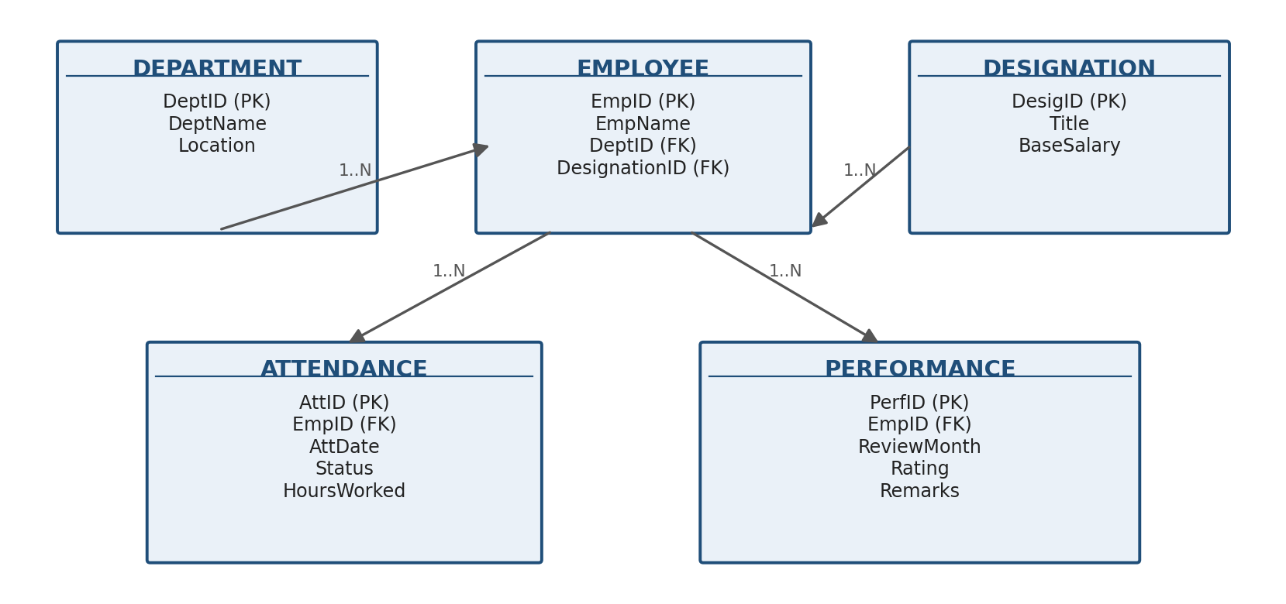

DEPARTMENT (DeptID PK, DeptName, Location)
DESIGNATION (DesigID PK, Title, BaseSalary)
EMPLOYEE (EmpID PK, EmpName, DeptID FK, DesignationID FK)
ATTENDANCE (AttID PK, EmpID FK, AttDate, Status, HoursWorked)
PERFORMANCE (PerfID PK, EmpID FK, ReviewMonth, Rating, Remarks)
Materialized view — monthly attendance summary
CREATE MATERIALIZED VIEW MonthlyAttendanceSummary AS
SELECT e.EmpID, e.EmpName,
DATE_TRUNC('month', a.AttDate) AS Att_Month,
COUNT(*) FILTER (WHERE a.Status='Present') AS Days_Present,
COUNT(*) FILTER (WHERE a.Status='Absent') AS Days_Absent,
SUM(a.HoursWorked) AS Total_Hours
FROM Employee e
JOIN Attendance a ON e.EmpID = a.EmpID
GROUP BY e.EmpID, e.EmpName, DATE_TRUNC('month', a.AttDate);
Materialized view — monthly performance summary
CREATE MATERIALIZED VIEW MonthlyPerformanceSummary AS
SELECT e.EmpID, e.EmpName, p.ReviewMonth,
AVG(p.Rating) AS Avg_Rating
FROM Employee e
JOIN Performance p ON e.EmpID = p.EmpID
GROUP BY e.EmpID, e.EmpName, p.ReviewMonth;

-- Periodic refresh (data is physically stored, unlike a normal view):
REFRESH MATERIALIZED VIEW MonthlyAttendanceSummary;
REFRESH MATERIALIZED VIEW MonthlyPerformanceSummary;
Decision rationale: attendance/performance dashboards are read frequently but the underlying raw logs change constantly — a MATERIALIZED VIEW pre-computes and physically stores the aggregated result so reports run instantly, at the cost of needing a periodic REFRESH, unlike an ordinary view which recomputes on every read.

